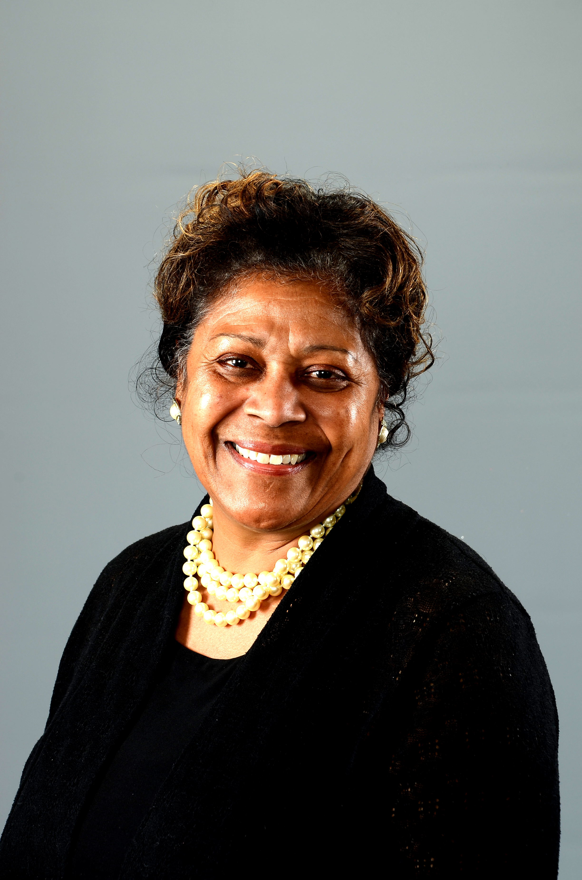 President’s Update - March 5, 2017

Greetings NAACP PA,

The NAACP PA is at the forefront of civil rights work in Pennsylvania. Your local Unit, and you as a member are essential to our success. Here is what happened this week.

NAACP PA attended and presented a workshop at the Black Conference of Higher Education which was held in Pittsburgh. We attended political events in Pittsburgh and visited the wonderful NAACP office there.

NAACP PA published its press release concerning Senator Eichelberger’s remarks concerning African American Students. Check our web site for that press release. http://pastatenaacp.org

NAACP PA processed complaints from across the state including:
PIAA issues at school basketball games
Police issues in counties where we have no Units
School issues of overt acts of racism

NAACP PA attended policy meetings this week:
Meeting with Governor Wolf’s Policy Analyst office to respond to 2017 Budget Proposal
Read the Budget proposal at: https://www.governor.pa.gov/2017-18-budget

Meeting with PA Department of Education “Equity and Inclusion Committee” in the ongoing work to address over acts of racism and sexism in public schools. This committee and the Governor’s Plan is a response to a call by NAACP PA for the Dept. of Education to address post election racists acts in our schools.
Action Alert on this issue:
Check our state web site home page for the Governor’s Safe School Response Plan - http://pastatenaacp.org Report incidents at schools within your jurisdiction to the State Conference President and follow the suggests in the Governor’s plan to address such experiences.

Your State Conference Think Tank convened in Harrisburg under the generous hosting of Harrisburg Branch President, Rev. Dr. Frank Allen. Watch for emerging results from this sub-committee – such as – a Weekly Update from your State President.
Yours in the work,
President: Joan Evelyn Duvall-Flynn, Ed. D.

WATCH FOR STATE ACTION ALERTS ON BILLS BEING CONSIDERED BY THE STATE LEGISLATURE!

