Bio of: Everett L. Butcher, Jr.

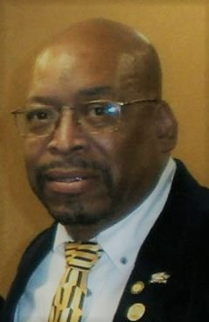

A veteran of over 20 years in the armed forces, continued public service, having founded and established numerous social programs and initiatives, along with having been either placed in elected office or appointed to various positions of leadership;

Everett has begun to emerge as one of the upcoming social and community activists advocating the protection and enhancement for quality of life. Not only a retired veteran,

He is the Lead Host of the the "Don't Get it Twisted"Radio Talk Show on WCHE 1520 am; and newly, on FM stations in the nation.

He is also an ordained minister who has developed programs and initiatives which are nationally and internationally recognized and/or endorsed.

