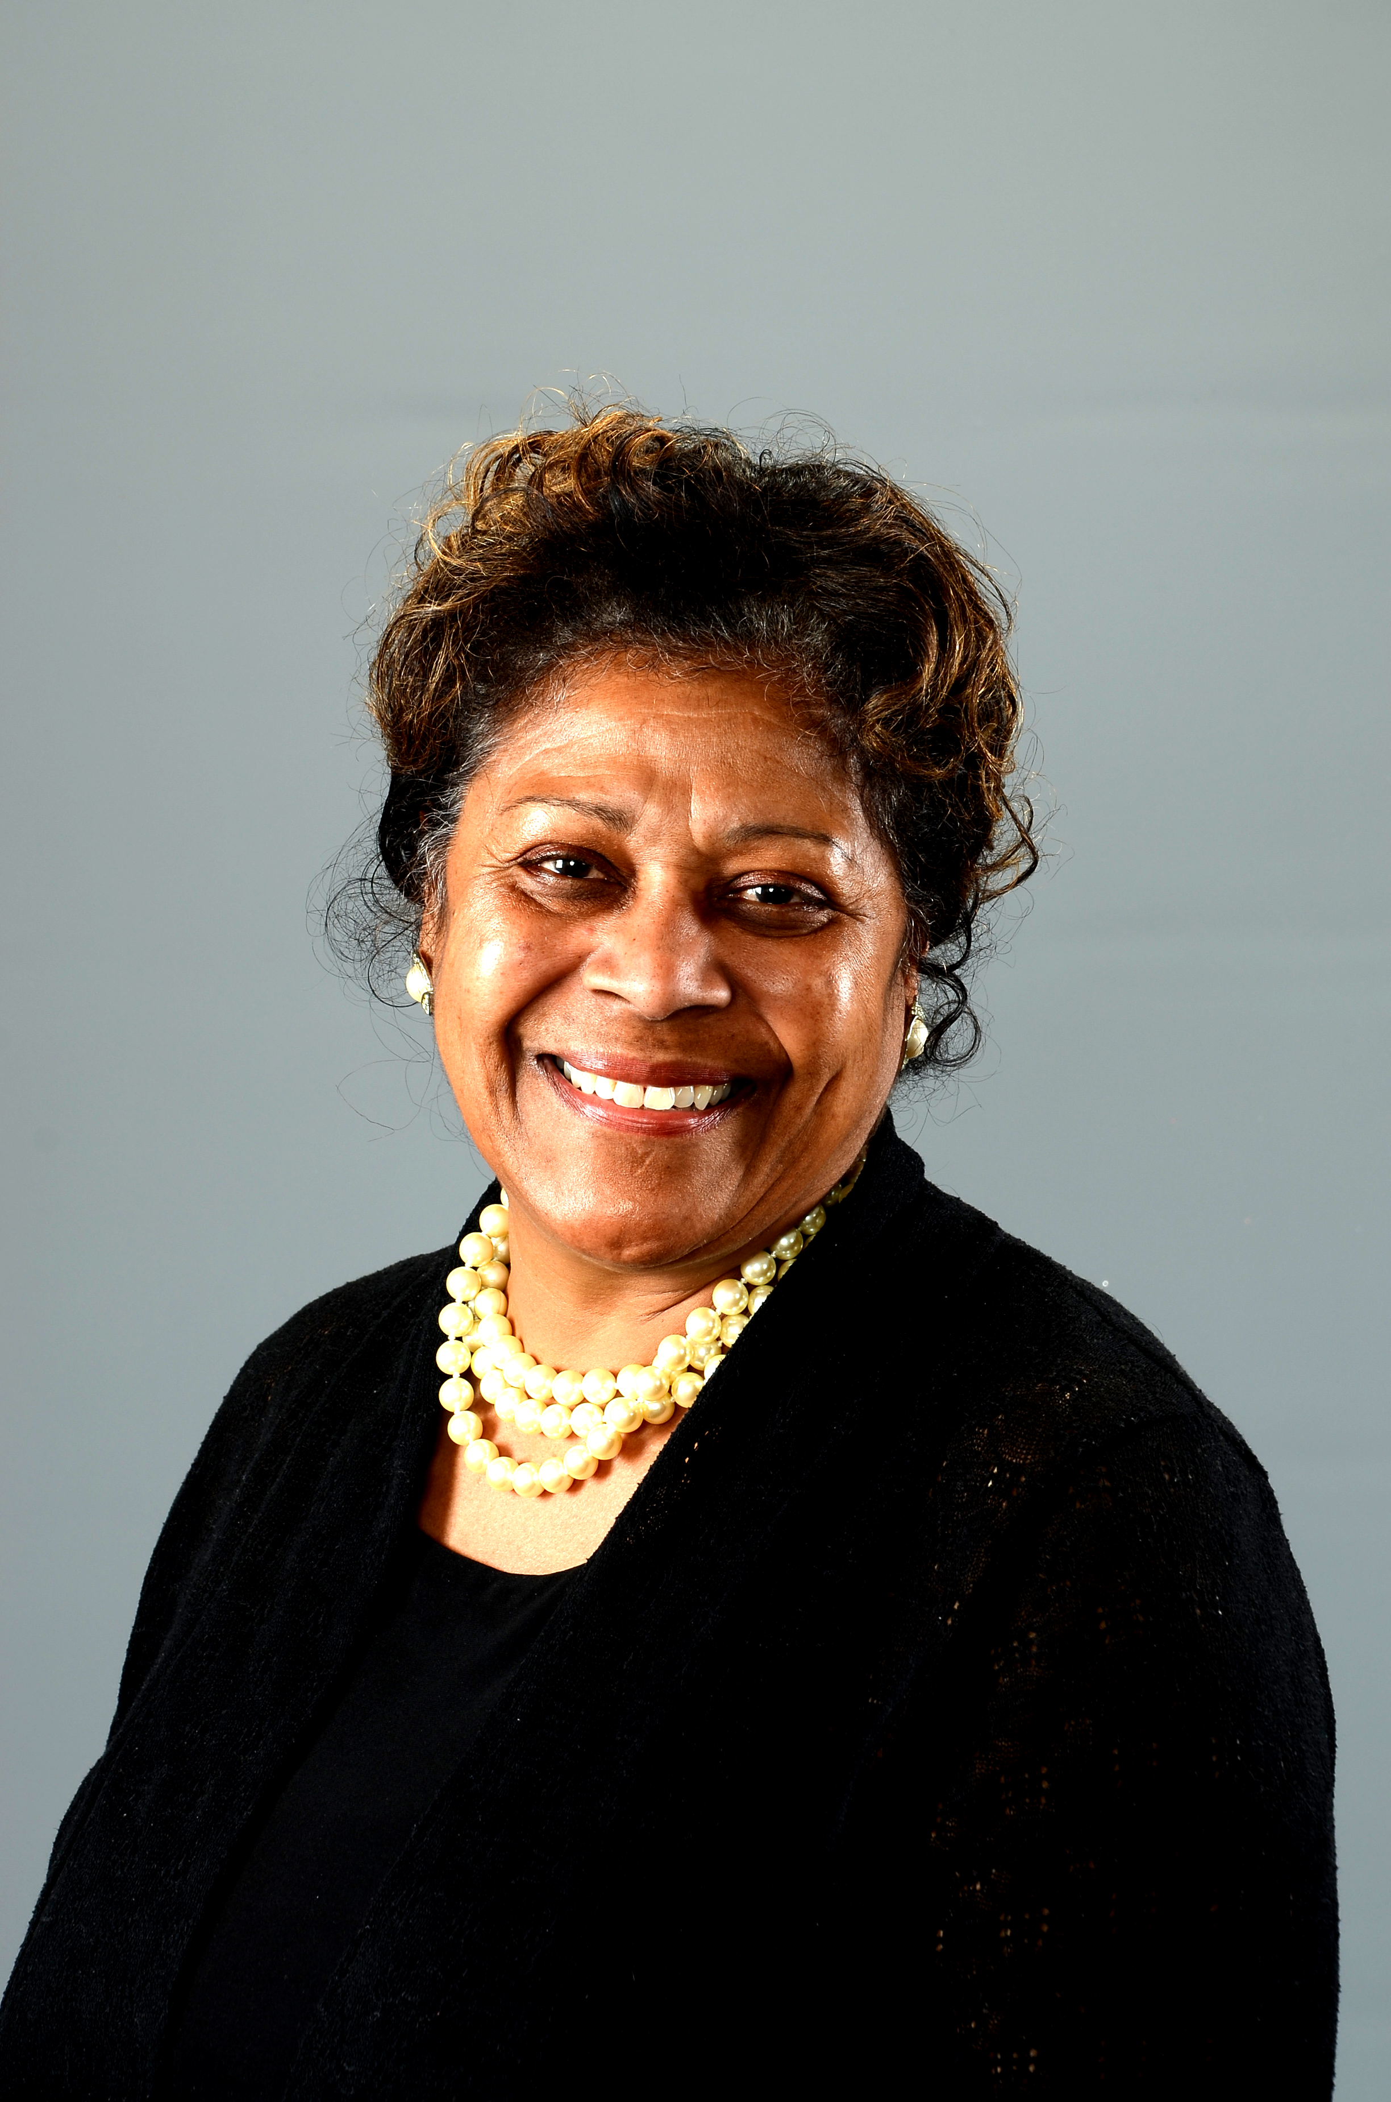 President’s Update - March 26, 2017

Greetings NAACP PA,

The NAACP PA is at the forefront of civil rights work in Pennsylvania. Our Branches, and you as members, are essential to our success. Here are some things you should know this week.

Thank you for carrying out the Action Alerts concerning the health care bill. Your work worked. Thousands of Pennsylvanian’s still have health care!

We met with Senator Eichelberger, Chair of the Senate Education Committee. Our follow-up Statement is attached to this week’s update.

There are overt acts of racism occurring around Pennsylvania. Some are at schools and colleges. Report these to the State President. We are following a process.

- Go to the state web site and scroll down the right side to the Governor’s Safe School Plan. Call the number at the end of the information and report the incident. This is important. We are in monthly meeting with the Department of Education about these incidents. We need them reported.

- We are working with the Department of Justice Conciliation Division to bring communities together to make it clear that these acts do not reflect the community values. This is important so that hate groups do not take advantages of the unrest. Branch presidents will be connected to the conciliation agent at DOJ. The Conciliation Division does not investigate or bring charges. The agent facilitates community discussions that lead to a public Resolution against hate acts.

- We have an interactive map on the state web site where we are pin pointing the locations of overt acts of racism. Check it out. Reported sites will be added.

Be sure to mail in your financial report! Send your assessment and pay the $100 late fee.

The Second Quarterly meeting is in Johnstown, PA on Sat. April 22. . Bring your Youth and College students!

Remember - We do civil rights! Stick to the Mission:
The mission of the National Association for the Advancement of Colored People (NAACP) is to ensure the political, educational, social, and economic equality of rights of all persons and to eliminate race-based discrimination.

Yours in the work,
President: Joan Evelyn Duvall-Flynn, Ed. D.

WATCH FOR STATE ACTION ALERTS ON ISSUES OF CONCERN

